A WORKFLOW FOR DESIGNING CONTOURED AXISYMMETRIC NOZZLES FOR EFFECTIVE COLD SPRAY COATINGS

F.L. Zavalan, A. Rona

School of Engineering, University of Leicester
University Road, Leicester, LE1 7RH, United Kingdom
Email: flz1@leicester.ac.uk

Abstract
This study aims to improve on the metal particle delivery of current commercial cold spray nozzles by performing a multi-objective optimization of the nozzle inner wall profile. This is done using two aerospace design codes based on the Method of Characteristics. A radiused throat combined to an S shaped divergent improve the impact pattern and velocity of the particles. This design approach can be built up in complexity to further improve the deposition performance of cold spray nozzles.

Keywords: cold spraying, nozzle design, process optimization, computational fluid dynamics (CFD)

1. Introduction
Cold spraying is increasingly attractive as a material coating technique as it retains the original properties of the feedstock and it can produce oxide-free deposits. This technique consists in accelerating powder particles to a high velocity by a high-speed flow and spraying them onto a substrate, where they plastically deform at impact and form a coating (Alkimov et al., 1990; Papyrin et al., 2007; Yin et al., 2016). Whereas many cold spray facilities use conical convergent-divergent nozzles for accelerating the particles, it is of interest to consider a workflow to design contoured axisymmetric nozzles that enhance the radial uniformity of the velocity in the carrier phase.
In this study, the performance of a conventional conical cold spray nozzle is compared with that of a new axisymmetric nozzle designed with a smooth throat and contoured for a parallel outflow. The new nozzle profile is obtained by a multi-objective optimization using two aerospace design codes based on the Method of Characteristics (MOC). A three-dimensional Computational Fluid Dynamics (CFD) model is developed to provide a preliminary assessment of the flow and particle behaviour in a lightly laden jet, in which well-dispersed titanium particles are accelerated by a compressible gas.

2. Numerical methodology
In order to improve the acceleration of the particles through the conduit, a bell-shaped nozzle is proposed, to replace the conical convergent-divergent shape of the cold spray nozzles in current use by industry. The design of the new nozzle is obtained by using the code developed by Alcenius and Schneider (1994) in conjunction with the CONTUR code (Sivells, 1978).
The new nozzle is designed by varying the nozzle inlet convergent angle, the throat radius of curvature, and the peak slope in the divergent part. A heuristic optimization is performed by varying systematically these three parameters, in a sequence of about 20 numerical experiments. The inlet diameter, throat diameter and overall length are kept the same as those of the nozzle it is based on, so it can replace it on the cold spray commercial system.
The baseline numerical set-up consists of a conical convergent-divergent nozzle, namely, the Out4 nozzle manufactured for the Impact Innovations 5/11 cold spray system from Impact Innovations GmbH. The performance of the baseline nozzle is tested by CFD. The CFD domain has a diameter of 600 mm and a length of 671 mm. The nozzle is supplied with compressed nitrogen at 5 MPa and 1373.15 K. The substrate is placed at an axial distance of 35 mm from the nozzle exit plane. The axial particle feeder has a diameter of 4 mm and it is located at the nozzle inlet. Titanium particles are injected at a constant rate of 3 g/s with an initial particle velocity of 10 m/s and an initial temperature of 298.15 K. Particles are assumed spherical and are injected in the converged flow solution by using a Rosin-Rammler particle size distribution.
This model uses the two-way coupling approach in ANSYS FLUENT® v19.5: the fluid phase is treated as a continuum, by solving the RANS equations (Eulerian reference frame), and the dispersed phase is solved by tracking a number of particles through the calculated flow field of the continuous phase (Lagrangian reference frame). More information about the numerical model used in this study can be found in (Zavalan and Rona, 2021).
To compare the performance of different engineering design solutions, it is often useful to translate the desirable outcomes into numerical values that can be prioritized by weight-averaging them. In this work, the authors have elected to define the penalty function Φ that the better design minimizes. This penalty function is defined as Φ = a(1-Z₁) + aZ₂ + 2aZ₃, where a = 0.25 is an adjustable coefficient that reflects the design intent. The first parameter, Z₁, represents the ratio of the mass-weighted particle speed evaluated just off the substrate to the maximum gas velocity. The second one, Z₂, is the mass-weighted standard deviation of the particle speed normalized by the mass-weighted mean particle speed, and the third parameter, Z₃, represents the coefficient of variation (COV), which is a point-to-point measure of the uniformity in the spread of the particles over the substrate face (Gunzburger and Burkardt, 2004).

3. Results and discussion
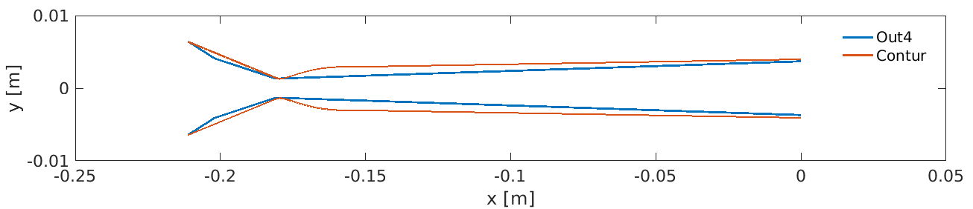
Figure 1. Nozzle profiles.

The lowest value of the function Φ is obtained for a nozzle with a divergent part 1.6 mm shorter than the baseline nozzle and an exit diameter of 8 mm. A nozzle inlet convergent angle of 12°, a throat curvature radius to throat radius ratio of 6 and an inflection angle of 7° characterize the redesigned nozzle. The performance of the best performing cold spray nozzle shape within the parameter space investigated is compared with that of the commercial conical convergent-divergent nozzle. In Figure 1, the radial profiles of the internal wall of the conical convergent-divergent nozzle, by the blue line, and of the re-profiled nozzle, by the red line, are presented. The baseline geometry is hereafter referred to as the Out4 nozzle and the redesign output as the Contur nozzle.
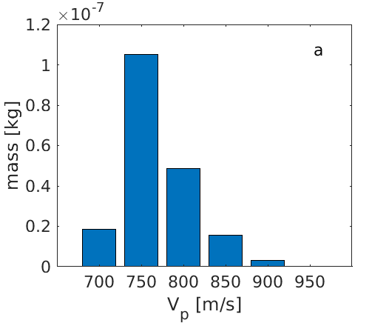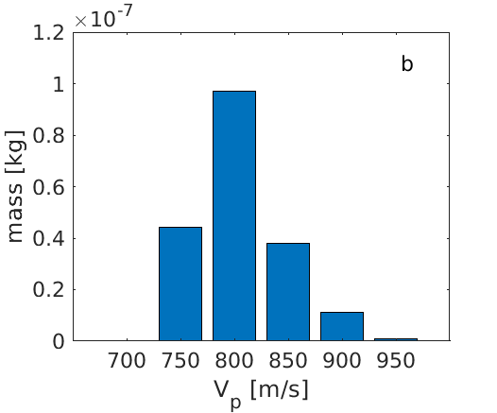
Figure 2. Mass weighted velocity distribution of titanium particles on impact with the substrate located at 35 mm from the nozzle exit (a) Out4 nozzle and (b) Contur nozzle.

Figure 2 presents the mass weighted velocity distribution of titanium particles at 35 mm from the nozzle exit plane. It can be observed that, by redesigning the nozzle, the particle speed distribution has changed, the titanium particles reaching a higher speed under the same conditions. The mean predicted particle speed is 743.36 m/s with the Out4 nozzle, while it is 36.49 m/s higher with the Contur nozzle. This indicates a two-fold advantage delivered by the redesign. On one hand, since the peak particle velocity is directly related to the particle kinetic energy, there is potential for a more energetic plastic deformation upon impact, which may improve the metal deposition characteristics. Additionally, the removal of lower velocity particles may reduce waste of powder feed, since lower velocity particles either rebound or poorly attach to the substrate.
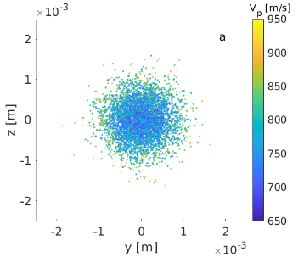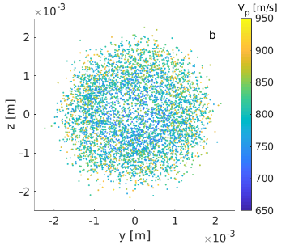
Figure 3. Radial spread of the titanium particles on impact with the substrate located at 35 mm from the nozzle exit. (a) Out4 nozzle and (b) Contur nozzle.

In Figure 3, it can be seen that the radial distribution of the particles is also affected by the redesign, by which the particles are visibly spread out more by the Contur nozzle. The baseline Out4 nozzle is predicted to direct most of the particles radially close to the nozzle axis. This is likely to cluster the particles so that some of them will strike the substrate in the same place. Over time, this particle overlap will increase the angle of the deposited material, thereby creating deposits with a conical profile, rather than an even layer, the latter being more desirable in a metal spray deposition process. Therefore, the redesigned nozzle produces a more spread out and even particle impact pattern.
The performance of the Out4 and of the Contur nozzles based on the penalty function parameters is also analyzed. On all three counts, the Contur nozzle outperforms the baseline nozzle. The Z₁ is 7.21% higher than that of the Out4 nozzle and the Z₂ is 5.51% lower. The most significant difference between the two nozzles is in terms of Z₃, this being 24.34% lower than that of the Out4 nozzle. Therefore, by redesigning the nozzle, its performance is improved by 19.96%, based on the change in Φ.

4. Conclusions
The new nozzle shape delivers a 4.91% higher mean particle velocity at the same operating conditions used by the industry standard nozzle. A 24.34% more radially uniform particle deposition profile is obtained, based on the coefficient of variation Z₃. These improvements are conducive to forming a more homogeneous metal coating. This nozzle design approach has excellent exploitation potential in cold spray coating technology as well as in additive manufacturing, to form better bonded deposits.

Acknowledgements: The PhD research of Florentina-Luiza Zavalan is funded by EPSRC (EPSRC CDT Grant number EP/L016206/1) in Innovative Metal Processing. This research used the ALICE High Performance Computing Facility at the University of Leicester.

5. References
Alcenius, T.J. and Schneider, S.P. (1994). Status Report for NASA Langley Grant NAG-1-1133: Development of a Code for Wall Contour Design in the Transonic Region of Axisymmetric and Square Nozzles, NASA-CR-194857.
Alkimov, A.P. et al. (1990). A Method of Cold Gas-Dynamic Deposition. Sov. Phys. Dokl., 35(12), 1047-1049.
Gunzburger, M. and Burkardt, J. (2004). Uniformity measures for point samples in hypercubes.
Papyrin, A. et al. (2007). Cold Spray Technology. Elsevier Science.
Sivells, J.C. (1978). A computer program for the aerodynamic design of axisymmetric and planar nozzles for supersonic and hypersonic wind tunnels. ARO Inc., ADEC-TR-78-63.
Yin, S. et al. (2016). Gas Flow, Particle Acceleration, and Heat Transfer in Cold Spray: A review. J. Therm. Spray Technol., 25, 874-896.
Zavalan, F.L. and Rona, A. (2021). Parametric Redesign of a Convergent-Divergent Cold Spray Nozzle. Thermal Spray 2021: Proceedings from the International Thermal Spray Conference, 221-228.

