TITLE:
Development of a digital self-management education programme to improve health behaviours in people with non-dialysis CKD

AUTHORS:
Courtney J. Lightfoot, Thomas J. Wilkinson, Alice C. Smith

ABSTRACT:
Background and aim:
Appropriate disease and healthcare management are key behaviours for health optimisation in people with long-term conditions including CKD. Effective self-management of health requires appropriate knowledge, skills and confidence. Digital health interventions are potentially appealing tools to improve knowledge and self-management behaviours, as well as actively involving individuals in their healthcare, particularly in the post-COVID-19 era. However, the development strategies and processes behind such interventions are poorly defined. Here we describe the systematic development of a digital self-management programme for people living with non-dialysis CKD which includes novel approaches to improving self-management and health behaviours.

Method:
Intervention mapping (IM) was used to guide the development of a digital self-management programme called ‘My Kidneys and Me’ (MK&M) to ensure that it can be implemented in clinical practice. The development process was guided by the first four steps of IM: (1) establish multidisciplinary and patient and public involvement (PPI) steering groups to describe the context of the intervention and programme goals; (2) identify objectives and determinants at early design stages to maintain a focus on the strategies adopted; (3) generate the programme components underpinned by appropriate psychological theories and models; (4) develop the programme content and describe the iterative process of refining the content and format of the digital programme for evaluation and implementation. The last two steps (adoption, implementation, and evaluation plan) will be evaluated alongside a forthcoming trial.

Results:
A multidisciplinary steering group was formed consisting of 23 healthcare professionals, researchers, and digital health experts who provided expertise in the clinical and psychosocial aspects of CKD, self-management, digital health, and behaviour change research. A PPI steering group of 12 patients and family members identified the needs and priorities of MK&M, providing feedback at relevant time points.

As a result of previous literature and input from both steering groups, MK&M was developed with the aim to improve and maintain self-management behaviours, including to improve knowledge, promote self-care skill, increase self-efficacy, improve well-being, and increase physical activity. These target behaviours were translated into key programme goals: 1) increase patient activation; 2) reduce health risks; 3) manage symptoms; and 4) increase physical function.

Based on patient input and needs, MK&M was designed to comprise educational (Learn about …) and behaviour change (How to …) sessions, health trackers (e.g. blood pressure, weight, fruit and veg consumption), symptom tracker, exercise trackers, goal setting features, and social support. For example, to improve symptom management behaviours, patients can use MK&M to: 1) learn about symptoms associated with CKD and strategies to help manage these symptoms; 2) learn how to recognise and keep track of their symptoms so that they can modify their lifestyle accordingly and speak to their healthcare professional if needed; 3) track their symptoms using a bespoke tool.

Conclusion:
Applying the IM framework enabled us to systematically use theory, empirical evidence, and practical perspectives in the development of MK&M. Our evidence- and theory-based online self-management programme provides ongoing support and guidance to people with CKD. The efficacy of MK&M to improve patient self-management behaviour is being studied in a multi-site RCT in the UK.

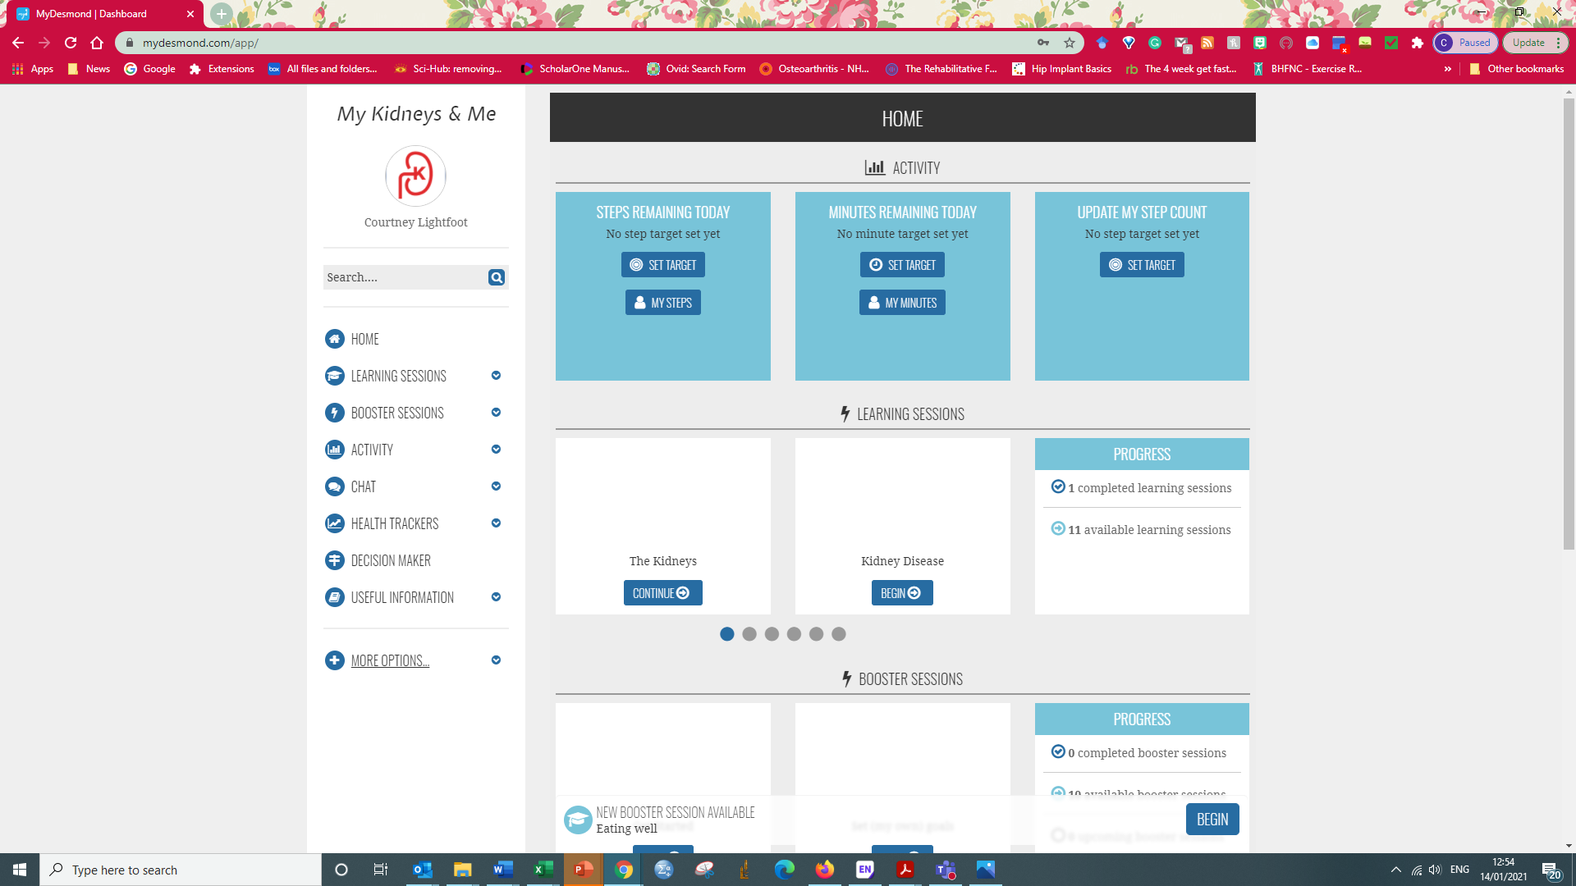
Figure:

Figure 1. My Kidneys & Me login page and home page

